Physics 3A/3B Score /20 Name _________________

Lab Validation - Spectra

- Choose one or two from the following classifications of spectral types to match each picture below. For each also choose an appropriate source that might be responsible for the spectrum shown. (NOTE - spectra may be a combination of two classifications, but you should only choose two if you are certain they both apply).

Classification Source

Line Emission An incandescent light bulb (filament)
Line absorption The solar spectrum
Band Emission White light passing through liquid chlorophyll Band Absorption Hydrogen discharge tube
Continuous Emission Fluorescent tube
a)

Classification/s ___ Line Emission ___________________________________

Source ______ Hydrogen discharge tube _________________
(2 marks)
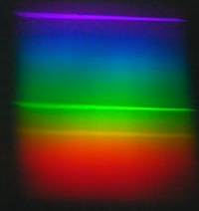
b)

Classification/s __ BOTH Line Emission + Continuous Emission

Source ____ Fluorescent tube __________

(2 marks)
c)
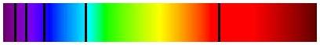

Classification/s ___ MUST HAVE Line Absorption +/- Continuous Emission ________

Source ______ The solar spectrum ________________
(2 marks)
d)

Classification/s _____ Continuous Emission ___________

Source _____ An incandescent light bulb (filament)__________
(2 marks)

e)


Classification/s ___ MUST HAVE Band Absorption +/- Continuous Emission _______

Source White light passing through liquid chlorophyll ____________
(2 marks)

- Explain why the spectrum observed when looking at the hot sun through a spectrometer, and the spectrum observed whilst looking at a white HOT solid are not the same.

- Both hot solids and the sun produce continuous spectrums (1)
- The solar spectrum has lines missing from it / dark lines (1)
- As the continuous spectrum goes through the outer layers of cooler gases, some of the frequencies are absorbed as by those gases (e.g. Hydrogen and Helium) (1)
- Thus we do not see those frequencies and they appear as dark lines. (1)
(4 marks)
- Describe in dot point form the production of the spectrum from a fluorescent tube

- High voltage excites atoms in mercury vapour (1)
- As electrons return to ground state they emit high energy photos of UV radiation…. (1)
- UV radiation is absorbed by atoms in phosphor coating inside tube, exciting electrons up multiple energy levels…. (1)
- Phosphor electrons cascade back down through a series of smaller energy jumps…. (1)
- Releasing photons of lower energy…(1)
- Which correspond to lower frequencies of light in the visible range (E=hf). (1)
(6 marks)

